The Pirate Law can be summarized as the following formula (sorry for the spanish and handwritting)



This means that, if the treasure consists in 100 coins to be share among 9 pirates, then each of the pirates will receive 11 coins and the captain only 1

We can change the formula to the following way:



Replacing using the information provided by the exercise:

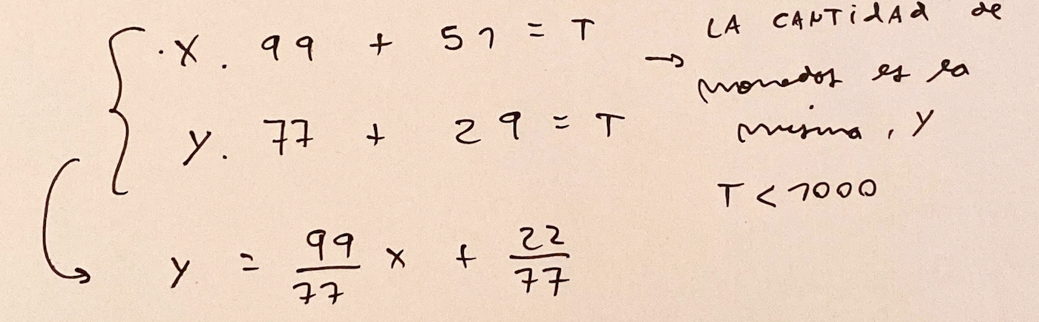

Because X and Y represent the number of coins for each pirate, this number should be a positive integer. And, together with the information that the total number of coins is less than 1000, we can find the solution. Creating a table with all the possible values of X and the corresponding value of Y we can find the solution:

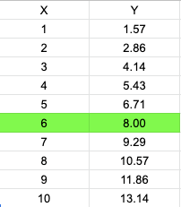

If X is equal to 6, then we know that the total number of coins is 645 (T = 645)

Finally, we want to find the number of pirates to choose in order to maximize the number of coins for the captain. We know that the higher the number of pirates, the bigger the rest of the division could be (rest is always lower than the divisor). Thus, going from high to low:

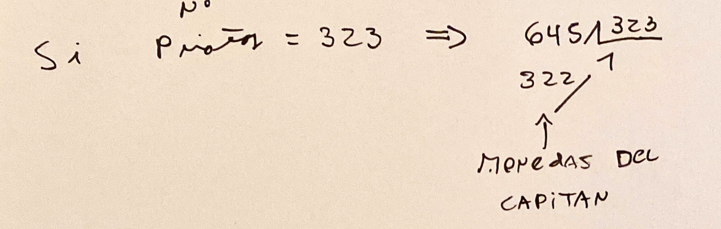

If there are 323 pirates, all of them will receive 1 coin and the captain the 322 that rest